PM Data Rat - supplemental. Q3 2015

Z score analysis

Here’s a plot of the volatile z scores (pre QC deletions) for the quarter:

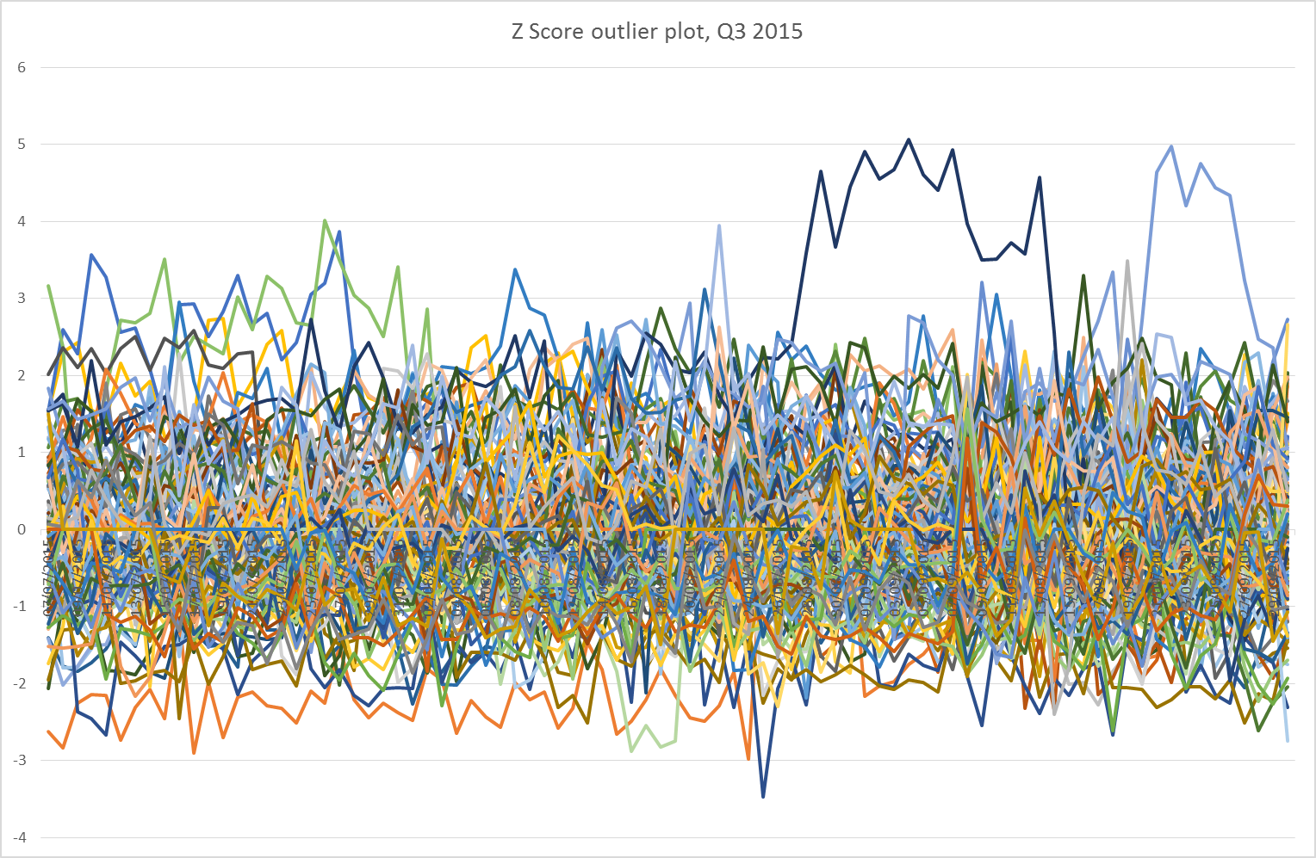

Anything outside z= +/-3 is an outlier.

Here’s a table of the outliers – we just need to check we have picked these up (or explained why we’re leaving them in) at the QC: (all higher than mean, unless stated)

Belfast Centre V10 – 10, 11, 20, 25, 26, 27 July

Ealing Horn Lane V10 – 7, 15, 20, 22, 23, 26, 27, 28, 31 July, 8 Aug, 10 Sep

Leamington Spa V2.5 – 28 Aug - 13 Sep

Leamington Spa RR V2.5 – 16 Sep

London Eltham V2.5 – 21 Aug

London Harlington V10 – 4 July

Norwich Lakenfields V10 – 18, 21, 22, 23, 24, 25, 26, 27 Sep

Norwich Lakenfields V2.5 – 22 Aug

Reading New Town V10 – 25 Aug (negative z)

Stoke Centre V2.5 – 19 Sep

Armagh Roadside (orange) is consistently between z= -2 and -3 for Jul-Aug. Low, but not enough to bin it. What we need to do now is get R Tools to automatically list all the potential troublemakers at the start of the ratification cycle to help ratifiers.

Bri 4 Dec 15